Translations and Rotations
Plot the original shape in the coordinate plane below.
A(6,10) B(10,10) C(10,6) D(11,6) E(8,3) F(5,6) G(6,6)
Once original points are plotted on the graph, follow the directions down below to translate or rotate the figure. **Remember to go back to the original shape for every transformation**
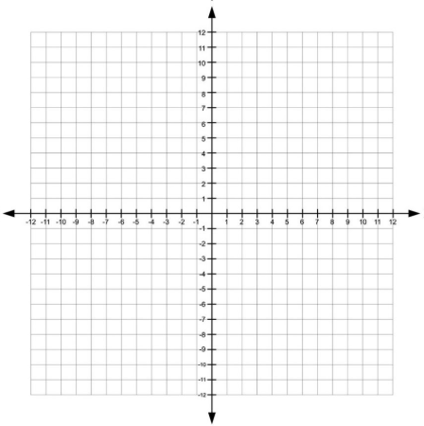

Directions:
- Translate: (x,y) (x – 10, y - 7)
A’( ) B’( )
C’( ) D’( )
E’( ) F’( ) G’( )
- Translate: (x,y) (x + 1, y – 9)
A’( ) B’( )
C’( ) D’( )
E’( ) F’( ) G’( )
- Rotate 90° Clockwise
A’( ) B’( )
C’( ) D’( )
E’( ) F’( ) G’( )
- Rotate 90° Counterclockwise
A’( ) B’( )
C’( ) D’( )
E’( ) F’( ) G’( )

- Rotate 180°
A’( ) B’( )
C’( ) D’( )
E’( ) F’( ) G’( )

