Theodor Schwann
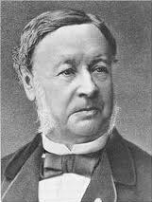
Theodor Schwann, a pathologist and cell biologist was born on December 7, 1810 in Neuss, Germany. He was the son of a goldsmith and, as a child, loved tinkering with mechanical devices. He studied at the Universities of Bonn, Warzburg and Berlin. While at Berlin, he studied under the pathologist Johannes Müller.
Schwann was a master microscopist who became known as the “Founder of Modern Histology” for his study of the anatomy of cells and tissues. In 1836, he discovered the digestive enzyme pepsin. Schwann was a friend of Matthias Schleiden and they discussed what he had discovered, that plants are made of cells. Schwann combined this knowledge with his own and determined that animals are also made of cells and came to the conclusion that all living things are made of cells. They also recognized that there are both unicellular and multicellular organisms. He published these findings in Microscopic Investigations on the Accordance in the Structure and Growth of Plants and Animals in 1839. Their conclusions would eventually become the Cell Theory.
In 1838, Schwann became a professor of anatomy and physiology at the University of Leeuven in Belgium. In 1848, he moved to the University of Liege, also in Belgium. While at the universities, he continued to study cells and made many important discoveries. He showed that yeast are organic organisms and that fermentation is a biological process. He discovered the cells that surround nerve fibers, which are called Schwann’s Cells in his honor. Schwann coined the term “metabolism” to describe chemical changes that can be observed in living tissue. In his later years, Schwann became interested in theological issues, but continued to study cells until his death on January 11, 1882 at the age of 71.
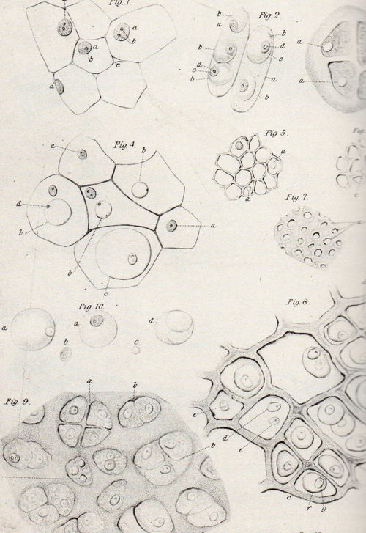

Diagrams of cell strustures by Theodor Schwann

