Name: ___________________________ Date: __________ Core: __________

**Statistics and Probability Practice**

1. A local newspaper of a New Mexico town intends to find if the mayor of the town is popular with its adult citizens. For accurate results, which of the following samples should be used by the newspaper?
2. A random sample of people from the mayor’s political party
3. A random sample of people selected from all adult citizens of the town
4. A random sample of people selected from all people registered with a political party
5. A random sample of people selected from all middle class citizens of the town
6. Estimate the number of times you have to throw a dice in order to roll the number six 50 times?
7. 100
8. 200
9. 300
10. 600
11. A student is randomly selected from a class of 32 students. What is the probability that the selected student is a boy, if there are 20 girls in the class?
12. 0.75
13. 0.25
14. 0.425
15. 0.375
16. A quarter coin is tossed two times. What is the probability that the coin will land heads up both times?
17. Hillary and Devin will collect data to find out where the seventh-grade students should take their field trip. Which group should Hillary and Devin survey to collect the best data?
18. the first 25 students through the lunch line
19. ten random people from each seventh-grade class
20. all the students in a dance class
21. twenty of their friends
22. Jeremy will roll a number cube, numbered 1–6, twice. What is the probability of rolling an even number, then the number 3?
23. 1/12
24. 1/6
25. 1/4
26. 2/3
27. The chart below shows the number of miles Sam drove each day for two weeks. What is the approximate difference in average daily miles between the two weeks?

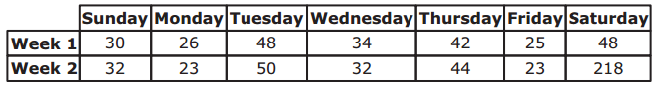

1. 96
2. 48
3. 34
4. 24
5. 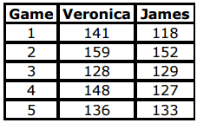Veronica and James are both on a bowling team. Below are their bowling scores. How much higher is Veronica’s median score than James’s median score?
6. 12
7. 10
8. 7
9. 3
10. 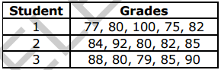The table below shows the grades for three students on five assignments. Which statement below is true about the mean absolute deviation (MAD) of the students?
11. MAD of Student 3 = MAD of Student 1
12. MAD of Student 2 = MAD of Student 1
13. MAD of Student 1 < MAD of Student 3
14. MAD of Student 1 > MAD of Student 2
15. Terry placed 6 number tiles labeled 4, 7, 10, 11, 14, and 21 in a box. He will pick one of the number tiles from the box without looking. What is the probability Terry will pick a tile labeled with an even number?
16. 2/3
17. 1/2
18. 1/3
19. 1/6
20. 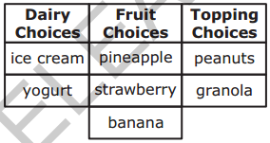The table below shows the different choices for making a shake at a restaurant. Joey will randomly select one dairy, one fruit, and one topping choice. What is the probability that Joey’s shake will be made with ice cream, pineapple, and granola?
21. 1/12
22. 1/6
23. 3/12
24. 3/7

**The accompanying box-and-whisker plot represents the cost, in dollars, of twelve CD’s. Look closely, some of the values in the five number summary are decimals.**



1. Which cost is the upper quartile?
2. What is the range of the costs of the CD’s?
3. What is the median?
4. Which cost represents the 100th percentile?
5. How many CD’s cost between $14.50 and $26.00?
6. How many CD’s cost less than $14.50?

**Find the probability of each series of events:**

1. Rolling an even number on the first roll of a standard number cube and rolling an even number on the second roll of the same cube.
2. Evan has 4 pennies, 3 nickels, and 5 dimes in his pocket. If he randomly chooses a coin, keeps it, and then chooses another coin; what is the probability that both are dimes?

**The accompanying box-and-whisker plot represents the scores earned on a math test.**

1. What is the median score?
2. 75
3. 70
4. 85
5. 77
6. What score represents the first quartile?
7. 55
8. 70
9. 100
10. 75
11. What statement is *not* true about the box and whisker plot shown?
12. 75 represents the mean score
13. 85 represents the 3rd quartile
14. 100 represents the maximum score
15. 55 represents the minimum score
16. A score of an 85 on the box-and-whisker plot shown refers to:
17. the third quartile
18. the maximum score
19. the median
20. the mean

**Find the probability of each series of events:**

1. A vase has 6 tulips, 10 daisies, and 12 roses. Find the probability of randomly picking a daisy, not replacing it, and then picking a tulip.
2. Lilly has the letters P R O B A B I L I T Y in a bag. If she chooses 2 letters without replacing the first, what is the probability that Lilly will choose a vowel and then not a vowel.

**Decide whether each event is dependent or independent:**

1. Tossing a coin three times
2. Pulling a sock out of a bag, putting it back, and picking another sock
3. Picking a piece of candy out of a bag, eating it, then picking another piece of candy