Tornadoes Fact Sheet

Tornadoes are violently rotating columns of air with circulation that reaches the ground. Tornadoes take the form of a funnel cloud and are accompanied by a loud, roaring noise.
Tornadoes:
- Are the most destructive of all the atmospheric phenomena with wind speeds that can be over 300 mph.
- Often strike with little or no advanced warning.
- Are extremely dangerous. One supercell storm can produce a series of tornadoes along the same general front line.

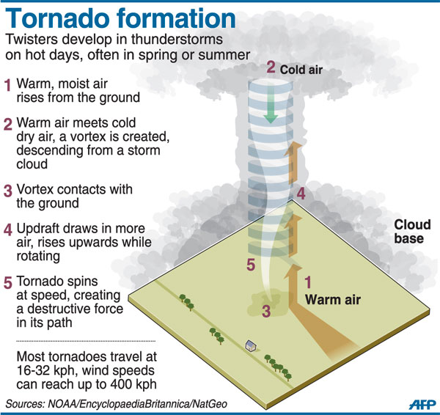

Tornado Danger Signs: Tornadoes may develop from Cumulonimbus (thunderstorm clouds) when warm, moist air is in advance of eastward-moving cold fronts. Watch for skies that turn suddenly dark and greenish (a phenomenon caused by hail) and with increasing wind speeds, and keep a particular lookout for the formation of funnel clouds.
- Large Hail: Tornadoes are spawned from powerful thunderstorms that often produce large hail.
- Calm before the Storm: Often just prior to tornado touchdowns, the winds may die down and the air may become very still; clear, sunlit skies are not uncommon right after a tornado.
- Clouds of Debris: Approaching debris clouds can mark a tornado’s location, even if a funnel is not visible.
- Funnel Clouds: A visible rotating extension of the cloud base is a sign that a tornado may develop. Tornadoes are evident when one or more clouds turn a greenish color and a dark funnel descends.
- Roaring Noise: High winds can cause a roaring sound often compared with a passing freight train.

Tornado Scales: The Enhanced Fujita Scale (EF Scale) rates the strength of tornadoes with intensity estimates through after-the-fact examination of the damage they produced using knowledge of the wind forces needed to damage or destroy various buildings and their component parts to estimate wind speeds.

EF Scale* | Wind Estimate  3-second Gust* | Typical Damage
0 | 65-85 mph | Light damage. Some damage to chimneys; branches broken off trees; shallow-rooted trees pushed over; sign boards damaged.
1 | 86-110 mph | Moderate damage. Peels surface off roofs; mobile homes pushed off foundations or overturned; moving autos blown off roads.
2 | 111-135 mph | Considerable damage. Roofs torn off frame houses; mobile homes demolished; boxcars overturned; large trees snapped or uprooted; light-object missiles generated; cars lifted off ground.
3 | 136-165mph | Severe damage. Roofs and some walls torn off well-constructed houses; trains overturned; most trees in forest uprooted; heavy cars lifted off the ground and thrown.
4 | 166-200 mph | Devastating damage. Well-constructed houses leveled; structures with weak foundations blown away some distance; cars thrown and large missiles generated.
5 | Over 200 | Incredible damage. Strong frame houses leveled off foundations and swept away; automobile-sized missiles fly through the air in excess of 100 meters (109 yards); trees debarked; incredible phenomena will occur.

*Source: NOAA http://www.spc.noaa.gov/faq/tornado/ef-scale.html

Tornado Awareness: Tornadoes can occur at any time of the year in the United States.
- In southern states, peak tornado occurrence is March through May, while peak months in northern states are June through August, with secondary tornado maximum occurrences in September through November.
- Tornadoes occur at all hours of the day and night but are most likely to occur between 3 and 9 p.m.
- Typically tornadoes move from southwest to northeast, but they have been known to move in any direction.
- The average forward speed of a tornado is 30 mph, but this may vary from nearly stationary to 70 mph.

Know the Difference: Tornado Watches and Warnings
- Tornado Watch: The National Weather Service’s Storm Prediction Center issues this announcement when conditions are favorable for the development of tornadoes in and close to the watch area. Watch sizes vary depending on the weather situation and usually are issued for 4 to 8 hours. Watches normally are issued well in advance of the actual occurrence of severe weather. -- Stay alert for tornado signs, closely monitor weather information and be prepared to move immediately to shelter if threatening weather approaches.
- Tornado Warning: The NWS issues a warning when a tornado is indicated by radar or sighted by storm spotters. Warnings can be issued without a tornado watch being in effect. Warnings usually are issued for about 30 minutes. -- Take shelter immediately!

Be Prepared: Plan Ahead to Seek Shelter

Know Where to Shelter:
- Go to lowest level available (basement or cellar).
- Find an inside room with no windows and strong walls.
- If in a mobile home, get out and go to the nearest sturdy building.
- Get under a piece of sturdy furniture, such as a workbench, or heavy table or desk, and hold on to it.
- Use your arms to protect your head and neck, or use a heavy blanket or pillow to help protect your head.
If in a Vehicle or Outside:
- Never try to outdrive a tornado in a vehicle because tornadoes can change direction quickly and can lift and toss your vehicle through the air.
- Leave the car immediately, and take shelter in a nearby building. If no building is nearby or you’re caught outside, lie flat in a ditch or depressed area, cover your head and watch for flooding.

Tornado Frequency Mapping

Directions: On the map for Station #2, complete the steps listed below using the Tornado Strikes data table.

- Color the areas on the US map green that have an average of 0-10 tornadoes per year.
- Color the areas on the US map blue that have an average of 11-20 tornadoes per year.
- Color the areas on the US map yellow that have an average of 21-37 tornadoes per year.
- Color the areas red on the US map that have an average above 38 tornadoes per year.

Average Annual Tornado Strikes: 1991-2010
State | Average Number of Tornadoes | State | Average Number of Tornadoes
Alabama | 44 | Montana | 10
Alaska | 0 | Nebraska | 57
Arizona | 5 | Nevada | 2
Arkansas | 39 | New Hampshire | 1
California | 11 | New Jersey | 2
Colorado | 53 | New Mexico | 11
Connecticut | 2 | New York | 10
Delaware | 1 | North Carolina | 31
Florida | 66 | North Dakota | 32
Georgia | 30 | Ohio | 19
Hawaii | 1 | Oklahoma | 62
Idaho | 5 | Oregon | 3
Illinois | 54 | Pennsylvania | 16
Indiana | 22 | Rhode Island | 0
Iowa | 51 | South Carolina | 27
Kansas | 96 | South Dakota | 36
Kentucky | 21 | Tennessee | 26
Louisiana | 37 | Texas | 155
Maine | 2 | Utah | 3
Maryland | 10 | Vermont | 1
Massachusetts | 1 | Virginia | 18
Michigan | 16 | Washington | 3
Minnesota | 45 | West Virginia | 2
Mississippi | 43 | Wisconsin | 24
Missouri | 45 | Wyoming | 12

