Rudolf Virchow
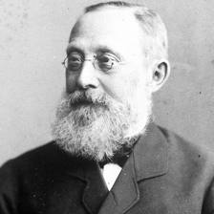
The man who became known as the “Father of Modern Pathology” was born to a modest farming family in Swidwin, Poland on October 13, 1821. He was an extremely bright student and received a scholarship for the University of Berlin. He earned his doctorate in 1843. Virchow was a physician, physiologist, archaeologist, anthropologist and politician, but his focus was on pathology. A Pathologist is a scientist who studies the causes and effects of diseases.
Virchow was able to expand on the Cell Theory with the concept that living cells come only from other living cells. He conducted extensive research on Leukemia and other cancers and discovered that many diseases have a cellular basis. He was chosen to study an outbreak of Typhus Fever in Germany and determined that the government was to blame for not having a system in place for clean water and proper waste disposal. While this angered the government and resulted in a temporary suspension from his position, he stood firm in his efforts to force reform.
Virchow published many works during his lifetime. He is best known for Cellular Pathology, which was published in 1858 and reported that the cell was the most fundamental unit of disease pathology. In 1856, he was named Director of the Pathological Institute in Berlin. He maintained this position for over 20 years. He left there because an entire pathological institute was created for him at the University of Berlin where he worked for the rest of his career. Virchow was famous for encouraging university students to “think microscopically”. .
He believed that medicine was a social science since it dealt with human beings and that politics was just medicine on a large scale. In 1859 he became a member of the Municipal Council of Berlin and began his political career as a civic reformer. He remained in politics for the rest of his life, always working to improve the lives and health of the citizens of Berlin.
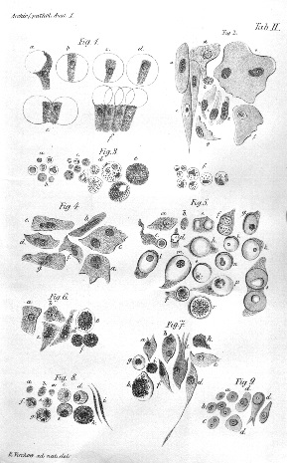
Virchow and his wife had three sons and three daughters. His children continued in the family line and made advancements in chemistry and anatomy. He was honored with the Copley Medal in 1892. The Copley Medal honors excellence in scientific research and has been awarded to one scientist every year since 1731. Virchow died of heart failure at the age of 80 on September 5, 1902.

Chancellor Bismarck, enraged at Virchow’s constant criticisms, has his seconds call upon the scientist to challenge him to a duel. “As the challenged party, I have the choice of weapons”, said Virchow, “ and I chose these”. He held aloft two sausages. “One of these”, he went on, “is infected with deadly germs; the other is perfectly sound. Let his Excellency decide which one he wishes to eat, and I will eat the other.” Almost immediately the message came back that the chancellor had decided to laugh off the duel. from Rudolf Virchow

