Robert Hooke
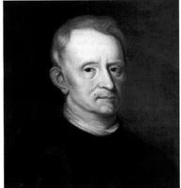
Robert Hooke was a natural philosopher, architect and a polymath who is known as the “English Father of Microscopy”. A polymath is someone whose skills span a number of different subject areas. Most of the early scientists, like Leonardo da Vinci, Galileo Galilei and Nicolaus Copernicus, are considered to be polymaths. Hooke believed that good science resulted from making observations on what you could see.
Robert Hooke was born on July 18, 1635 on the Isle of Wight in England. He received most of his early education at home due to poor health. He was curious about his natural surroundings and was interested in mechanical works and drawing. At age thirteen, he entered the Westminster School. He went on to attend the University of Oxford. While there, he was an assistant to Robert Boyle. Boyle is regarded as one of the founders of modern chemistry. In 1662, Hooke was appointed Curator of Experiments to the Royal Society and maintained this position until his death on March 3, 1703.
Hooke developed his own version of the microscope and it was the best available at the time. Using this microscope, Hooke studied thin slices of cork. He observed what looked like little rooms. He named these small structures cells. The word cell is from the Latin word for small compartment, cellula. He observed a variety of other organisms with his microscope and recorded his findings in a book called Micrographia that was published in 1665. This book was even a best-seller at the time.
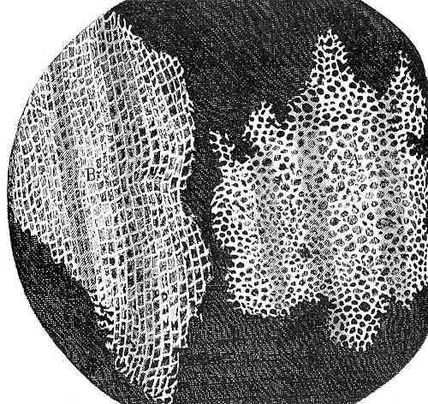
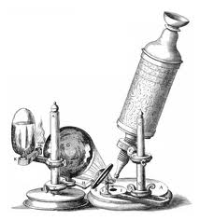
Robert Hooke made a number of contributions in addition to his most well-known work with his microscope. He figured out how to determine the distance to a star and formulated the theory of planetary motion. He created the Law of Elasticity, which states that an elastic body stretches in proportion to the force that acts upon it. He designed the iris diaphragm used in cameras to control the exposure. Hooke was the first to use the balance wheel in a watch and devised improvements that made pendulum clocks more accurate. As an architect, he was appointed Surveyor of London and designed a number of buildings built after the Great Fire of London in 1666 destroyed much of the city.

Robert Hooke’s Hooke’s drawing
Microscope of cork cells from
Micrographia

