Name:______________________ Date:_______________
Volume Review
Find the volume of each figure. Round your answers to the nearest tenth, if necessary.
1.  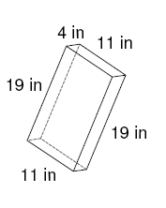 | 2.  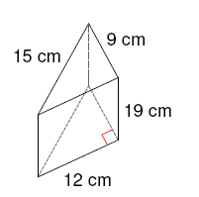
3.  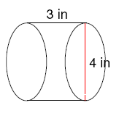 | 4.  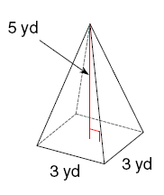
 | 6.
7.  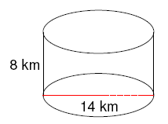 | 8.  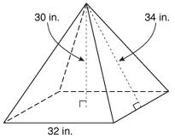
9.  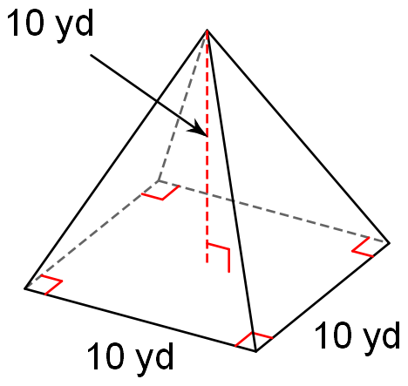 | 10.  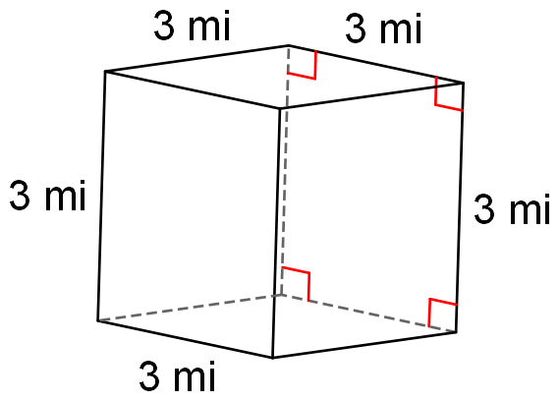
11. A cylindrical container with a radius of 10 cm and a height of 5 cm is filled with water. If the total mass of the filled container is 2 kg, what is the mass of the empty container? | 12. Find the height of a square pyramid that has a volume of 873.18 m³ and a base length of 12.6 m.
13. Mr. Bean needs to ship a large order of coffee mugs. Each mug I packed in a cube box that is 6 inches on each side. His large shipping box is 3 ft. x 3 ft. x 2 ft. How many mugs can he fit in the large box? | 14. A rectangular prism pool has dimensions of 25 feet by 15 feet and is 4 feet deep. If water costs $0.03 per cubic feet, how much will it cost to fill the pool?
15. Ben wants to buy enough potting soil to fill a window box that is 42 inches long, 8 inches wide and 6 inches high. If one bag of potting soil contains 576 cubic inches, how many bags should he buy? | 16. A can of lemonade concentrate has a diameter of 3 inches and a height of 4.5 inches. If the concentrate dissolves in 3.5 cans of water, how much water must be added?
17. A marble monument is in the shape of a square pyramid. The side length of the base is 5 feet. The height of the pyramid is 5 feet. Find the volume of the pyramid. Use the fact that 1 cubic foot of marble weighs about 170 pounds. To the nearest pound, how much does the monument weigh? | 18. Find the height of the pyramid.  