Name:____________________ Date:___________ Period:_______

Ratios and Proportions Test Review (7+)

1. | A parking lot contains 18 American cars and 63 foreign cars. Write the ratio of American cars to foreign cars in simplest form. | 2. During a trip, a car traveled 249.2 miles in 4 hours. How many miles per hour did the car travel?
3. | Two drinks are on sale at a store. Drink A c | osts $1.28 for 16 ounces. Drink B costs $2.16 for
 | 24 ounces. Determine the unit rates, and fi | nd which drink costs less per ounce.
4. | Seven bananas contain 3.5 milligrams of  Vitamin B6. How many bananas contain 9.31 milligrams of Vitamin B6? Round to the nearest whole banana. | 5. Terry paid $8.75 for 5 pounds of pears. At this rate how many pounds of pears could she buy with $61.25?  a. 7 lb b. 12 lb  c. 13 lb d. 35 lb
6. There are 14 girls in the seventh grade and 85 boys in the eighth grade. Each grade has 100 students. Which statement correctly compares the ratio of boys to total students in each grade?  - The eighth grade ratio is greater.  - The eighth grade ratio is lesser.  - Both ratios are equal.  - I have no idea! |  | 7. Write a proportion and solve to find the missing measurement.  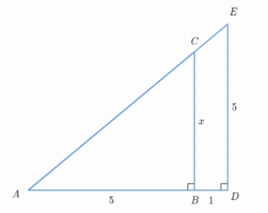

8. Find the distance between Raleigh and Detroit if they are 16 cm apart on a map with a scale of 3 cm : 160 miles. (round to the nearest tenth) | 9. If a 42.9 ft tall flagpole casts a 253.1 ft long shadow then how long is the shadow that a 6.2 ft tall woman casts?
10. A girl that is 4 feet tall is standing next to the Empire State Building in New York City. The girl’s shadow is 3.2 feet long. If the Empire State Building is 1454 feet tall, how long would its shadow be? | 11. Jimmy is building a model plane. If 3 inch = 12 feet. What is the scale?
12. A house is 25 feet high. On a scale model of the house, the height is 5 inches long. What is the scale of the model? (Simplify) | 13. The following chart shows the pay a babysitter made for different hours of work. Does the babysitter’s pay represent a proportional relationship?  Number of hours Pay  0 $0  2 $15  3 $24.75  11 $107.25
14. Fill in the following table and identify the constant of proportionality.  Minutes Words Typed  12 96  6  3  1  Constant of Proportionality = _________ | 15. Write a proportion and solve to find the missing measurement.  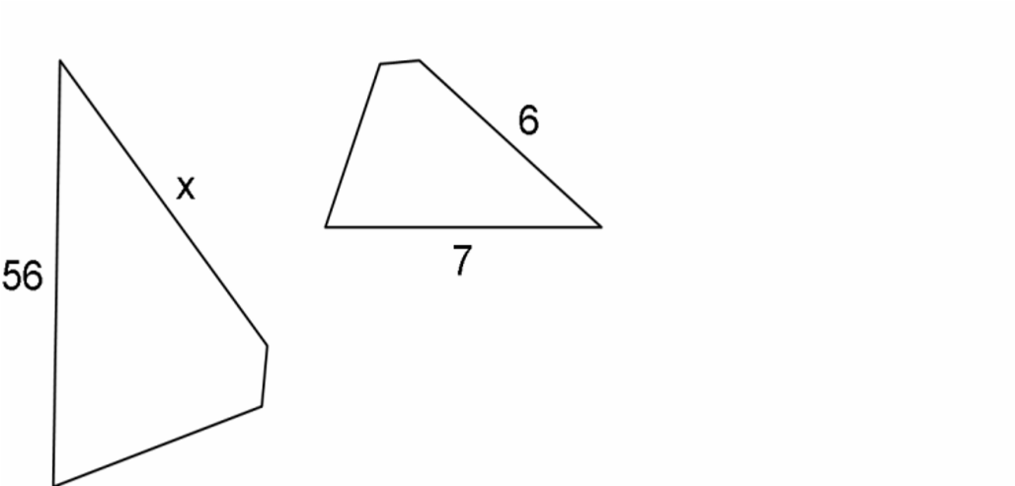

16. Use the graph below to answer the following questions.

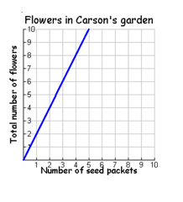
Find the constant of proportionality. _________________

Write an equation that represents the graph. _______________

If you use 8 seed packets, what is the total number of flowers? ________________

If there are 30 flowers in Carson’s garden, how many seed packets did he use? ____

17. Write the slope-intercept form of the equation.  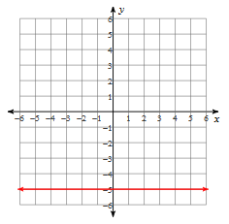 | 18. Write the slope-intercept form of the equation.  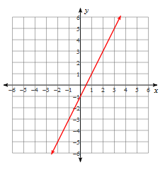
19. Write the slope-intercept form of the equation.  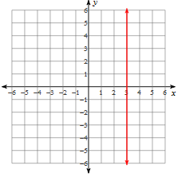 | 20. Write the slope-intercept form of the equation.  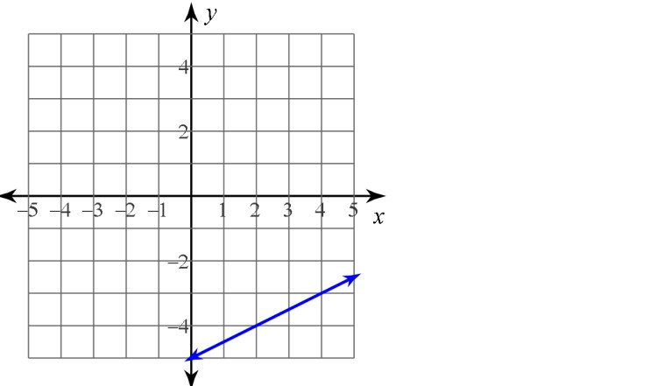
21. Draw a graph.  y = -3  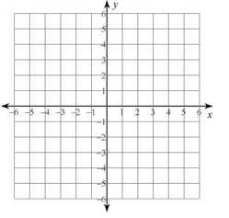 | 22. Draw a graph.  x = 4
23. Draw a graph.  $y=\frac{2}{3}x-2$ | 24. Draw a graph.  $y=-2x+3$

