Name: _______________________________ Date: _______________ Period: _________

Review: Rates, Ratios, Proportional Reasoning and Slope

1. A parking lot contains 24 hybrid cars and 93 electric cars. Write all three forms of the ratio comparing hybrid cars to electric cars. |  | 2. During a trip, a car traveled 465.3 miles in 6.25 hours. How many miles per hour did the car travel?
3. Two drinks are on sale at a store.  Drink A costs $1.36 for 15 ounces. Drink B costs $3.14 for 32 ounces. Determine the unit rates, and find which drink costs less per ounce. |  | 4. Determine whether the following ratios are proportional:  $\frac{14}{19}$ and $\frac{164}{222}$  - no b. yes
5. Which equation represents the proportional relationship in the table?  x y  3 -14.25  5 -23.75  8 -38  12 -57  - y = x + (4.75)  - y = x + (- 4.75)  - y = 4.75x  - y = -4.75x |  | 6. The cost of notebooks at the school store is shown in the table below.  Number of Notebooks Cost  2 $1.30  3 $1.95  4 $2.60  5 $3.25  What is the cost of one notebook?
7. A worker at a tire shop can install 4 new tires in 1.25 hours. At this rate how long would it take the worker to install new tires for 96 cars if each car will receive 4 tires? |  | 8. What is the value of n?  $\frac{15}{n}=\frac{37}{71}$
9. Trail mix was made by combining 6 cups of almonds and 3 $\frac{1}{2}$ cups of M&M’s. Using the same ratio of almonds to M&M’s, how many cups of M&M’s would be needed for 24 cups of almonds? | 10. A group of students will be taking a field trip and there needs to be one chaperone for every 9 students. How many chaperones are needed for 135 students?
11. Harry ran 4 miles. He started at 9:20 and finished at 10:05. What was Harry’s average speed in miles per hour? | 12. Find the missing variable:  $$\frac{n+3}{20}= \frac{19}{40}$$
13. Fill in the following table and identify the constant of proportionality.  Minutes Words Typed  8 104  5  3  1  Constant of Proportionality = _________ | 14. John paid $320 for 5 tickets at an amusement park. Each of the tickets cost the same price. Write an equation that represents the cost, C for n tickets?
15. North Carolina Public Schools spends about $101,600 for every 9 students. If Wake County Schools spends money proportionally to this amount, how much will they spend for 10,200 students?  17. How much flour per teaspoon of oil, if there is $\frac{4}{7} cup of flour$ for $\frac{1}{2} teaspoon of oil?$ | 16. Oliver reads 26 ½ pages of a book in $1\frac{1}{8}$hours. Express his reading speed in pages per hour.  18. What is the constant of proportionality? What does it represent?  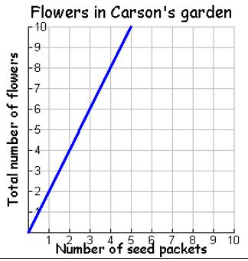  A. The constant of proportionality is 1/2. This means 1 seed packet will give you 2 flowers.  B. The constant of proportionality is 1/2. This means 1 flower will come from 2 seed packets.  C. The constant of proportionality is 2. This means 1 seed packet will give you 2 flowers.  D. The constant of proportionality is 5. This means 1 flower will come from 2 seed packets.
19. Find the slope and y-intercept.  m = ______ b = _________  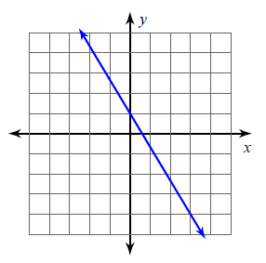 | 20. Graph the line that is formed by the equation y = -3x + 8.  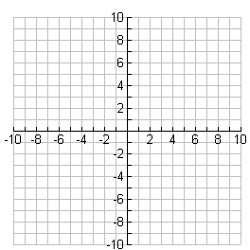
21. Write the equation of the line.  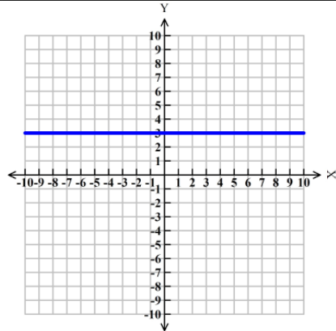 | 22. Graph $y=\frac{1}{3}$x – 4
23. Determine the slope of the line that passes through the points  (-1,1) and (4,3). Show your work. | 24. Determine the slope of the line that passes through the points  (-15,3) and (-19,-13). Show your work.
25. Four students wrote expressions using the variable t  below. If t represents a positive integer, whose  expression has the smallest value?  Student Expression  Amy -6(11b + 10)  Bob 3(6b – 9)  Chris -7(-3b + 19)  David -5(-4b – 3) |  | 26. Simplify:  1.3(-5.7 - 1.6x) + 1.9(2.7 + x)
27. The rectangle has a perimeter of 130 units.  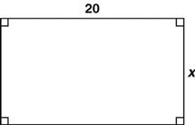  Write and solve an equation to find the width of the rectangle. |  | 28. What is the distance between -3 $\frac{2}{3}$ and $\frac{5}{8}$ on the number line?
29. A band will sell CDs of their music at their concert for $7.25 each. The band ordered 1200 CDs at a cost of $3.50 each. Write and solve an inequality that represents the number of CDs, n, the band needs to sell to make a profit of at least $2000.

