Name:__________________________
Proportions Quiz Review
1. Out of 80 students surveyed, 22 are girls. What is the ratio of boys to the total number of students surveyed? | 2. Uncle Randy used 5 cups of flour to make 8 dozen muffins. How many cups of flour would he need to make 20 dozen muffins?
3. Is the graph proportional? Why or why not? If so, what is the Proportionality?  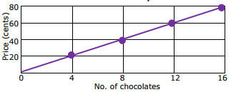 | 4. Isabella made necklaces with beads. Create a graph to determine if the quantities of beads and necklace are proportional. If the quantities are proportional, what is the constant of proportionality?  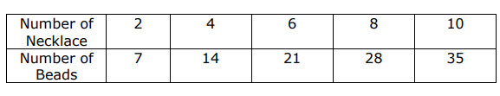
5. You need to scale the following shape by a factor of 2.5, what will be the area of the new rectangle?  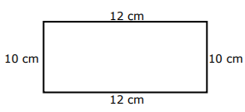 | 6. On a map, 2 inches represents 60 miles. If a line between two cities measures 9 inches, how many miles apart are they?
7. On a scale drawing, 3 inches represents 50 miles. If a line segment between two points measured 7 inches, how many miles would it represent? | 8. Solve for x.  $$\frac{2}{9}= \frac{15}{x}$$
9. The Painted Desert is a section of high plateau extending 150 miles on northern Arizona. On a map, the length of this desert is 5 cm. What is the scale? | 10. The scale of a map is 1.25in. = 80 mi. If two cities are 4.75 inches apart on a map, how many miles apart are the cities?
11. Fifty out of 125 eighth graders took summer school. What is the ratio of total number of students to the number of eighth graders taking summer school? Write in 3 different ways. | 12. It costs $3.49 for 1 ½ pounds of meat. How much does it cost per pound?
13. Solve for x.  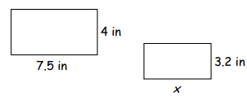 | 14. Find w.  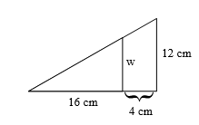
15. Ruth is at the park standing next to a slide. Ruth is 5 feet tall, and her shadow is 4 feet long. If the shadow of the slide is 4.8 feet long, what is the height of the slide? | 16. At a local animal rescue center, the ratio of dogs to cats is 7:5. If there are a total of 120 dogs and cats the center, how many of them are dogs?

