Name: __________________________ Date: ___________
Spiral Review Quarter 4 Week 1 Calculator Inactive Period: _________

Answers

- ______________

- _______________

3) _______________

4) _______________

5) _______________

6) _______________

7) _______________

8) _______________

9) _______________

10) ______________

1. A circus rents a rectangular building that has floor dimensions of 50 by 100 feet. The building can fit 2 circus rings shaped like circles, each with a diameter of 42 feet. To the nearest square foot, how many square feet of the floor are not taken up by the 2 circus rings? | 2. A rectangular playground has an area of 7125 square yards. The width of the playground is 75 yards. What is the length of the playground?
3. What is the area of a circle with a circumference of 56.52 inches? | 4. Calculate the Mean Absolute Deviation (MAD) for the following set of data:  78, 66, 78, 75, 63
5. A jar contains 12 green tokens, 6 red tokens, and 2 black tokens. What is the probability that two red tokens are chosen and then a black token (all without replacement)? | 6. Find the value of x.  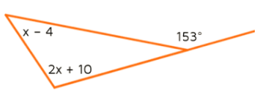
7. Find the value of x.  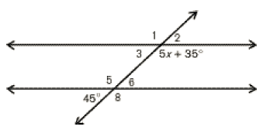 | 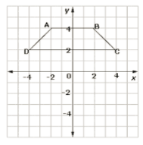  8. Find the area.
9. Find the value of x.  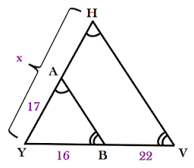 | 10. Mrs. Smith paid $125 to have her hair colored and cut. If she tips her hairdresser 18%, what was her total bill?

Weekly Warm-Up’s

Monday | Tuesday
Wednesday | Thursday
Friday | Important Information

