Name: __________________________ Date: ___________
Spiral Review Quarter 2 Week 1 Calculator Inactive Period: _________

Answers

1) _______________

2) _______________

3) _______________

4) _______________

5) _______________

6) _______________

7) _______________

8) _______________

9) _______________

10) ______________

1. Solve for the variable.  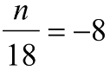 | 2. Solve for the variable.  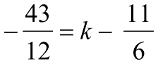
3. Solve for the variable.  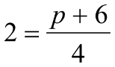 | 4. Solve for the variable.  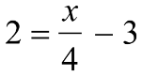
5. Solve for the variable.  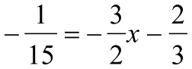 | 6. Solve for the variable.  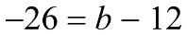
7. Solve for the variable.  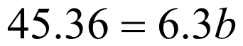 | 8. Solve for the variable.  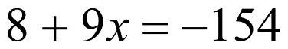
9. Solve for the variable.  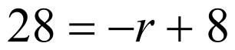 | 10. Solve for the variable.  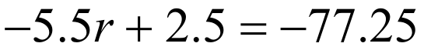
Weekly Warm-Up’s

Monday | Tuesday
Wednesday | Thursday
Friday | Important Information

