**Compositions of Transformations** Name: ___________________________

Composition of Transformation: A composition is a transformation in which a second transformation is performed on the image of a first transformation.

**Guided Examples:**

Given DEF with D (3, 6), E (-3, 6), and F (0, -3). Find the image points after:

1. 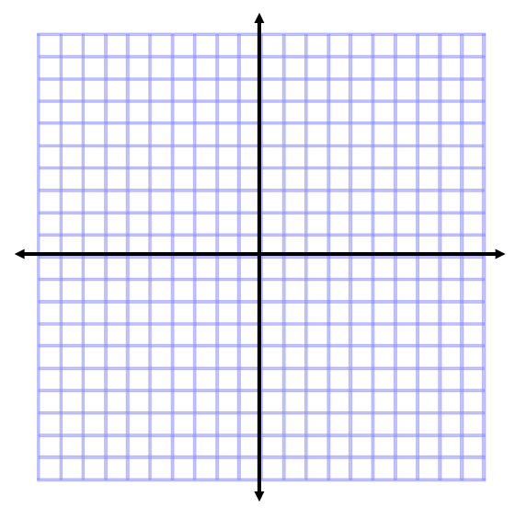 A reflection over the x-axis, then a dilation of 

Complete one transformation at time—IN ORDER!

1. A translation of (x, y) → (x - 5, y + 2) then a rotation of 90° counter clockwise



c. Triangle DEF has vertices D (3, -4), E (2, -2), and F (6, 0). Find the coordinates after a translation of (x, y) → (x, y - 2) and a reflection over the y-axis.

Given DEF with D (1, 4), E (5, 5), and F (3, 1). Find the image points after:

1.  A rotation of 180° counter clockwise, then a dilation of 2.
2. Triangle ABC has vertices A (3, 2), B (-1, -3), and C (3, -2). Find the coordinates after a translation of (x, y) → (x + 3, y) and a reflection over the y-axis.