Activity: Modeling Mitosis and Meiosis
Name _____________________
Date ______________________

Goal: To model the steps in the process of mitosis and meiosis and develop a better understanding of the differences during the two types of cell division.

Background Information: The growth and development of every organism depends on the precise replication of the genetic material during each cell division. The instructions for the precise timing of development, growth and maturation are contained within the DNA of each cell. Every cell contains this set of information. The cell cycle is the sequence of events that encompasses the period of cell division. This process involves the division of the cell’s nucleus and cytoplasm. There are two types of cell division: mitosis and meiosis. New body cells are formed by mitosis, and meiosis is a specialized type of cell division that results in sex cells – sperm and eggs.

Materials:
Mitosis and meiosis template
Mitosis kit
- 8 pipe cleaner pieces of Color A ________________, 8 pipe cleaner pieces of Color B ________________ in total (fill in the color in your kit)
  - 4 single pipe cleaners in Color A
  - 4 single pipe cleaners in Color B
  - Single pipe cleaners equal one chromosome
  - 2 sets of 2 pipe cleaners connected with a bead in Color A
  - 2 sets of 2 pipe cleaners connected with a bead in Color B
  - Two pipe cleaners held together by a bead (the centromere) equal one chromosome duplicated into two new strands (chromatids), each of which becomes a duplicate chromosome when the centromere splits at the beginning of anaphase
Meiosis kit
- 10 pipe cleaner pieces of Color C ______________, 10 pipe cleaner pieces of Color D__________________ in total (fill in the color in your kit)
  - 6 single pipe cleaners in Color C
  - 6 single pipe cleaners in Color D
  - Single pipe cleaners equal one chromosome
  - 4 pipe cleaners (2 sets of 2) connected with a bead in Color C
  - 4 pipe cleaners (2 sets of 2) connected with a bead in Color D
  - Two pipe cleaners held together by a bead (the centromere) equal one chromosome duplicated into two new strands (chromatids), each of which becomes a duplicate chromosome when the centromere splits at the beginning of anaphase
*DO NOT REMOVE BEADS OR SEPARATE PIECES*

Procedure:
- Work with your table group. Arrange the pipe cleaners from the Mitosis kit on the Mitosis template.
- Arrange the pipe cleaners from the Meiosis kit on the Meiosis template. The first circle represents a parent cell about to undergo meiosis. The pipe cleaners represent 2 pairs of chromosomes.
- Have your models checked by the teacher.
- Draw the model you created. Make sure you use colors to represent your exact model.
- Count all pieces and return the mitosis pieces and meiosis pieces to the correct kits for the next class.

Model and Questions:
- What I Observed: Make a drawing of the models you created.
- What I Learned: Complete the chart comparing mitosis and meiosis.

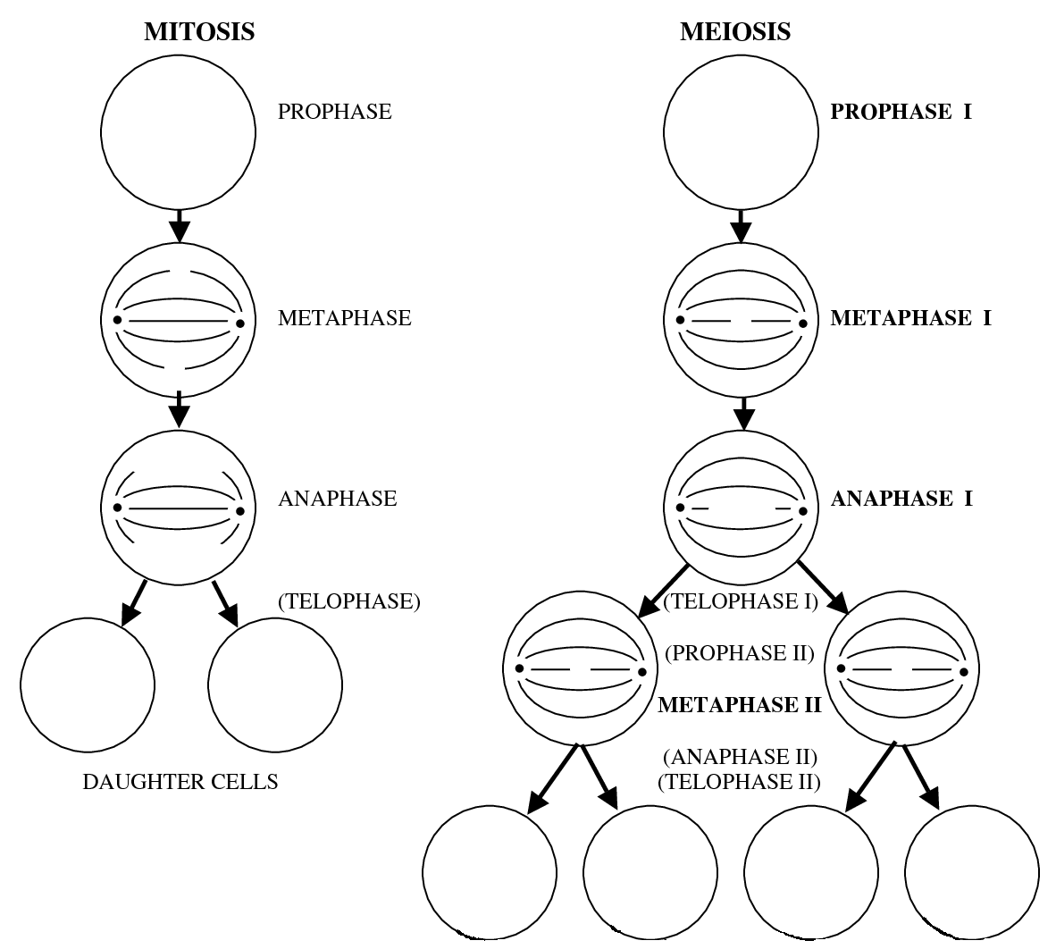
What I Learned | Mitosis | Meiosis
Number of chromosomes at the start
Number of resulting chromosomes at the end
Number of nuclear divisions
Number of resulting daughter cells
Are daughter cells similar or different from the parent?
Type of cell that undergoes division
Type of reproduction
Purpose of cell division

