Interphase | - Cytoplasm separates and two new cells are formed.  - Different in plants (cell wall forms down the center) and animals (cell membrane pinches in). | 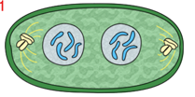
Prophase | - Chromosome pairs line up at the equator (center of cell).  - Spindle fibers attach to the chromosomes at the centromere. | 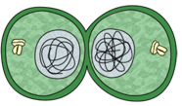
Metaphase | - Mitosis begins during this phase.  - Nucleolus and nuclear membrane disappear.  - Centrioles appear and move to opposite ends of cell.  - Spindle fibers begin to stretch across the cell.  - Chromosome pairs or sister chromatids become visible (attached to one another by a centromere). | 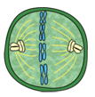
Anaphase | - Two new nuclei form.  - Chromosomes change to chromatin (threads rather than rods).  - Mitosis ends. | 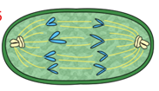
Telophase | - Chromosome pairs (sister chromatids) separate and move to opposite ends of the cell. | 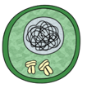
Cytokinesis | - Cell’s resting phase. Cell grows to mature size.  - Cell spends 90% of its time in this phase.  - Cell copies/doubles its chromosomes and prepares for cell division (mitosis). | 