Meiosis Diagram Notes
Name _____________________________
Item # ___________________
Use the diagrams on page 121 C to label each phase of Meiosis I and Meiosis II. Briefly describe what happens during each phase.
4.
3.
1.
2.

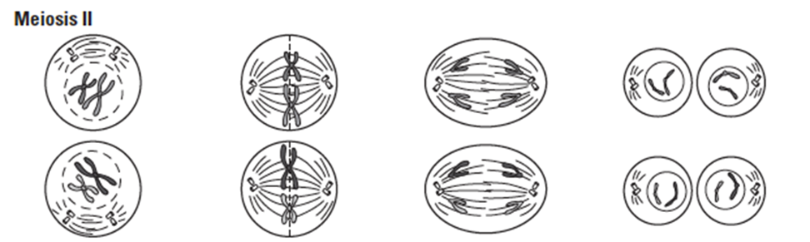
8.
7.
6.
5.

Meiosis Summary Notes
Complete the notes from pages 117-122 C summarizing meiosis.

Meiosis is necessary for sexual reproduction. During sexual reproduction two cells combine.
- One cell containing genetic information comes from the _____________________.
- The other contains genetic information from the _____________________.
- The cells combine into a completely new cell, which becomes the _________________________.

Most human cells (body cells) contain _____________ chromosomes (the full number of chromosomes that is normal for a human being).

Any cell that contains the full number of chromosomes (two sets) for a species is a 2n cell, also called ________________ cell.

Reproductive cells are called _____________________________ and differ from body cells.
- The cells contain _______________ the usual number of chromosomes (one chromosome from each pair).
- Gametes are ___________cells or haploid cells.
- Human gametes contain _______________ unpaired chromosomes.

Gametes are found only in the reproductive organs of plants and animals.
- An ___________ is a gamete that forms in the reproductive organs of a female.
- ______________ is the gamete that forms in the reproductive organs of a male.

Body cells divide by mitosis.
- Mitosis produces ____________ daughter cells, each containing exact copies of the chromosomes in the parent cell.

Cells divide twice during meiosis.
- During meiosis, a single cell goes through ___________ cell divisions, meiosis I and meiosis II.
- Meiosis takes place only in the _______________________________ tissues of an organism.
- Before meiosis begins, the chromosomes of the parent cell are ______________________.
- A cell that is ready to divide contains __________ copies of each chromosome pair – twice as many chromosomes as usual. The two copies in a pair are called ____________________________.

Identify four ways in which meiosis differs from mitosis.
1.

2.

3.

4.

