Matthias Schleiden
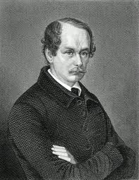
Matthias Schleiden was born on April 5, 1804 in Hamburg, Germany. He earned his degree in law from Heidelberg in 1826 and opened a law office in his hometown of Hamburg. Despite the fact that his law office was successful, he found that he greatly disliked the work. He returned to school to study medicine, but became interested in Botany, or the study of plants, due to the influence of one of his professors. He is well known for his work as a botanist and not as a lawyer.
Unlike the botanists of his day who simply named and described plants, Schleiden investigated plants on a microscopic level. In 1838, his microscopic study of plants led him to the conclusion that all plants are made of cells. This later became the first part of The Cell Theory. He also proposed that an embryonic or new plant came from a single cell. He believed that the nucleus of the cell was involved in the creation of the new plants. What he believed to be the role that the nucleus played in cell division was later proven to be incorrect, but he correctly identified that the nucleus was involved. His idea that the cell was the common structural unit of all plants created a shift in scientific thinking. Scientists paid more attention to the cellular level of living processes and that led to many scientific discoveries.
In 1839, he became a Botany professor, first at the University of Jena and later at the University of Dorpat. He returned to Germany in 1863 and became a private teacher there until his death at the age of 77 on June 23, 1881. His focus on the microscopic aspects of plants caused such a shift in the science of botany, that he became known as the “Reformer of Scientific Botany”
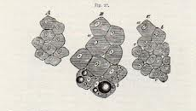

Matthias Schleiden’s plant cell diagrams

