Human Body Systems Review
I. Respiratory System:
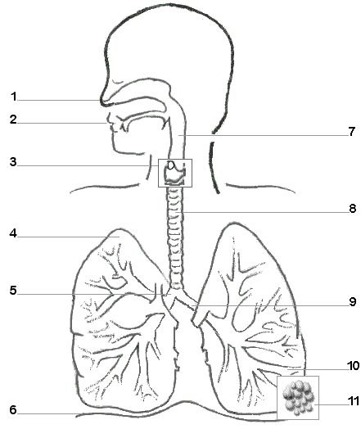
1. Label the following diagram Word Bank:
trachea pharynx mouth alveoli nasal cavity right lung left lung larynx left bronchi right bronchi bronchiole diaphragm epiglottis

2. Describe the role of the diaphragm in the
breathing process.

3. Explain how gas exchange occurs in the alveoli.

II. Excretory System
1. Label the following diagram.
bladder kidney ureter vena cava urethra
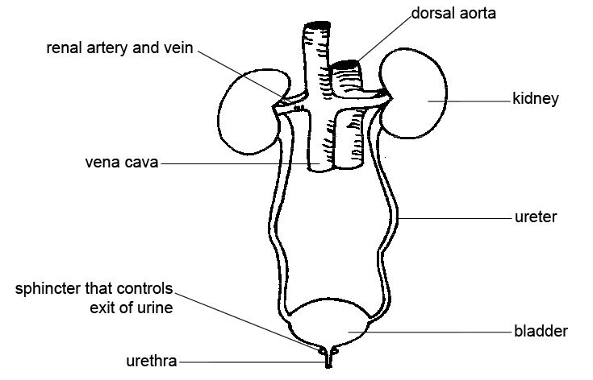
2. Explain how the nephrons in the kidneys remove wastes from the body.

3. Complete the chart below for how the different body systems work to remove wastes from the body.
Body System | Waste(s) removed | How the system removes the wastes
respiratory
digestive
urinary
Integumentary (skin)

III. Digestive System
1. Label the diagram with the organs of the digestive system: mouth, salivary glands, esophagus, gall bladder, large intestine, liver, pancreas, small intestine, stomach, rectum, anus.
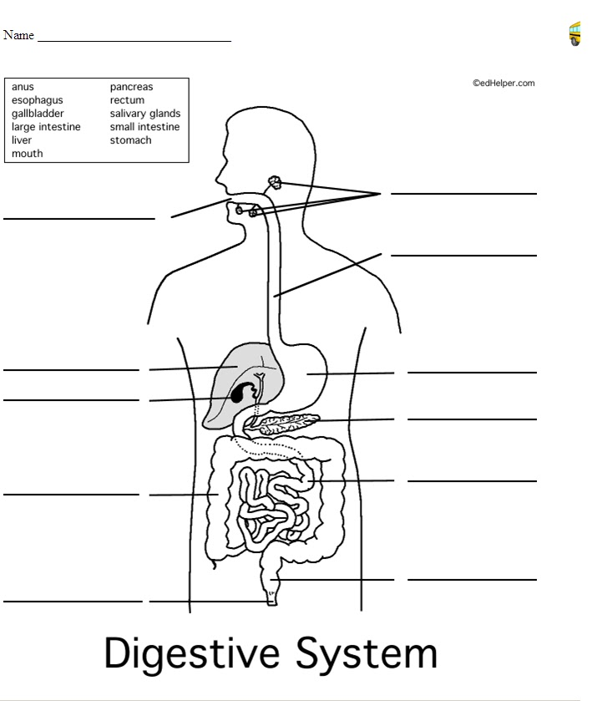

2. Describe the path food travels through the digestive system beginning with the mouth.

3. Describe the role of the pancreas, the gall bladder, and the liver in digestion.

4. Describe chemical and mechanical digestion including their role in digestion and where they take place.

5. Explain peristalsis and its role in digestion.

