Energy Transfer Word Art Notes
Everyone will create one page of “Word Art” after reading the article about energy transfer in Earth’s Atmosphere. Word Art Notes are notes that include pictures or other images, written text, and are typically rather colorful. Here are some examples:
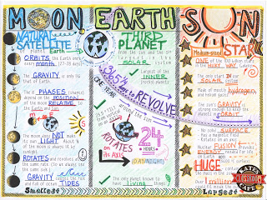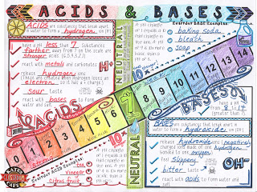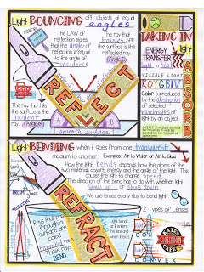
Use the following format for your notes:
- Use the other side of this paper.
- Include the title of the article and a related image.
- Include the three vocabulary terms with descriptions (conduction, convection and radiation) - each with correlating images.
- At least three additional important concepts from the article with correlating images.
- A six sentence summary about the transfer of heat energy in Earth’s atmosphere with related images.
- Use creativity and color!
- Fill the entire piece of paper.

Scoring Rubric | Point Value | Points Earned
Title of article with picture | 10
Three vocabulary words with descriptions and pictures | 60
Three additional concepts with images | 10
Six sentence summary with images | 10
Presentation: fills page; uses color and creativity | 10
Total | 100

