**Energy & Electricity Guide**

**Fuels & How Humans Obtain Fuel:**

Fuels are substances that release energy when they burn. Some fuels are better than others - e.g. one fuel may be easier to store, give off more heat and produce less pollution. Energy is the ability to ‘do some work’ - everything that happens needs energy (e.g. heating; cooking; lighting; movement of vehicles; and keeping us alive)!

A fuel is something that can release energy, making it useful for us to ‘do some work’ such as moving a car; running across a field; heating a room; sending a rocket into space, etc. Energy can be found in many different forms, such as light, heat, sound, electrical, kinetic (movement), nuclear, etc. Food is required by the human body, along with oxygen, so that cells can *respire*. (Remember, respiration occurs in every cell – it is the process of releasing *energy*.) Every cell in our body respires, converting this food (glucose) into *energy* (needed for growth; repair; movement, etc…). Different foods have different amounts of energy in them – this is measured in kilojoules (kJ) and calories (cal). This information is shown on the labels of foods, as well as showing you what is contained within them.

**Fossil Fuels**

Fossil fuels include **coal,** **natural gas,** and **oil.** They formed millions of years ago from the remains of living things. Coal was formed from plants, and oil and natural gas from sea creatures. When the living things died, they were gradually buried by layers of rock. The buried remains were put under pressure and chemical reactions heated them up, gradually changing into fossil fuels. Coal is used in power stations and to heat some homes. Natural gas is the gas we use for cooking and heating. Crude oil is separated into lots of different substances at oil refineries, including camping gas (propane), petrol, diesel, jet fuel and kerosene.

**Energy Origins (Renewable & Non-renewable)**

Fossil fuels are non-renewable energy resources - once they have all been used up they cannot be replaced. Renewable energy resources can be replaced, never running out. Energy can be transferred from many different resources - in non-renewable resources such as fossil fuels. Energy is stored chemically in the fuel, and burning them releases this energy. Energy can also be transferred from renewable resources, such as solar cells, where energy is absorbed from sunlight and turned into electricity.

Nearly all the energy we use originally came from the sun. Heat and light from the sun provide us with energy directly. Plants also store the sun’s energy through photosynthesis (utilizing light to make sugar from carbon dioxide and water). Coal, oil and natural gas were formed from the remains of dead plants and animals (the energy in these fuels came from the bodies of the plants and animals). The animals got their energy from the plants they ate, and the plants got their energy from the sun. Solar power utilizes sunlight directly. Wind is caused by the sun heating up the Earth (convection currents). Waves are caused by the build up of this wind. Hydroelectric power relies on water movement (which fell as rain after being evaporated by the sun’s energy). *Only tidal energy (caused by the sun and moon’s gravity); nuclear energy (energy stored within uranium); and geothermal energy (heat from the Earth) do not originate from the sun.

**Simple Electric Circuits (Symbols, Conductors & Insulators)**

Electricity is the flow of electrical power in the form of electrons. Electricity is a useful secondary energy source – most energy sources (like coal, oil, nuclear, wind etc…) can be converted into electricity. An electric circuit is a loop made up of wires and other components through which electric current can flow from an electrical supply (battery). An electric current needs two things:

* Something to make the electricity flow (e.g. a battery or power pack)
* A complete circuit

Without these two basic things, an electric current will not flow. Not all materials can be used to build a circuit. Conductors are materials, which allow electric current (the flow of electricity - electrons around the circuit) to flow through them. Insulators are materials which do not allow electric current to flow through them. Electric current will only flow if the electrons can travel freely (metals are good conductors). If the electrons cannot move freely (such as in wood) then electricity cannot flow.

A **circuit diagram** shows how a circuit is set

up using symbols. Circuit diagrams are a short-cut

method of drawing circuits. The diagram on the

right is a faster way of drawing the circuit on the left.

For electricity to flow from a battery to light up a

light bulb, there must be a complete path from the

positive terminal on top of the battery to the

negative terminal on the bottom on the battery. (+ is the longer line)

|  |  |
| --- | --- |
| **Electricity flows through circuits:** paths of conductors (usually wires). Any break in the circuit will cause the circuit to fail, just like a break in a pipe lets water leak out of a water system.  **Examples:**  Unsuccessful ways to light a bulb:  Picture 40  Successful ways to light a bulb:  Picture 42  A break in a circuit is any spot where an insulator is in the way of the electricity’s flow. Paper, plastic, or even an air gap can keep electricity from flowing. | |
| A **closed circuit** does not have any gaps or breaks; the light lights up. | An **open circuit** has a break in it; the light bulb will not light up. |



Devices in the circuit do work, which slows down (restricts) current.

The flow of electrons we call current travels through closed circuits.

These three quantities are linked in ANY circuit. Change one of them and one or both of the others will change. When you have multiple components in a circuit, they can be connected in **series** or in **parallel**. Current is not used up by the components in a circuit.

**Series Circuits (Current & Voltage)**

In a series circuit, the light bulbs are connected one after the other. The current is the same at any point in a series circuit. As more bulbs are added to the circuit they all get dimmer. This is because as more bulbs are added the resistance increases, reducing the flow of current. Having a circuit with many bulbs in it causes a lower current at every point in a series circuit. In a series circuit, if a light bulb breaks, all the components stop working.

Voltage (the driving force, which pushes the current around the circuit) changes, depending on which component the voltmeter is placed across (because each component has a different resistance). The total voltage of the cell is shared between the components, so adding up the voltage cross all the components gives our supply voltage.

**Parallel Circuits**

In a parallel circuit, the bulbs are connected side by side. In this circuit, the current splits at the junctions, some going one way, some going the other. The current (# of electrons) which go through each branch depend on the resistance (anything in the circuit, which slows the flow of electrons down) of the component. For example, if branch 1 has a high resistance, then not many electrons will pass through it, and instead more will pass through branch 2.

In a parallel circuit, if a lamp or component breaks, the components on the other branches keep working. Unlike a series circuit, the lamps stay bright if you add more lamps in parallel. The current, which passes through each component, depends on its resistance (the lower the resistance, the bigger the current which flows through). The total current flowing around the circuit is equal to the total of all the currents through the separate branches. Voltage stays the same in a parallel circuit – it’s the same regardless of the branch you measure because each electron still carries the same amount of energy (the same voltage).

|  |  |
| --- | --- |
| **Series Circuit –** one path, one loop  Picture 43 | **Parallel Circuit –** multiple paths, multiple loops  Picture 44 |

The table below shows some of the symbols that are used to represent the parts of an electric circuit.

|  |  |  |
| --- | --- | --- |
| **Symbol** | **Name** | **What it’s used for** |
| Picture 39 | Wire | Path that allows electrical current to travel |
| Picture 34 or Picture 34a | Battery Cell(s) | Provides electrical energy |
| Picture 31 | Switch | Allows circuit to be opened or closed (off or on) |
| Picture 37 or Picture 38 | Light bulb | Converts electrical energy into heat and light |
| Picture 32 | Resistor | Restricts (reduces) the flow of electricity |
| motor symbol | Motor | Electric motor |
| connected wires symbol | Connected wires | Connected crossing of wires |
| unconnected wires symbol | Not connected wires | Wires not connected |
| voltmeter symbol | Voltmeter | Measures voltage, high resistance, connected in parallel |
| ammeter symbol | Ammeter | Measures electrical current, has nearly zero resistance, connected serially |
| wattmeter symbol | Wattmeter | Measures electrical power |

**#___** Name_____________________________

**Energy and Electricity** Date _________________ Period ______

**Open and Closed Circuits**

1. 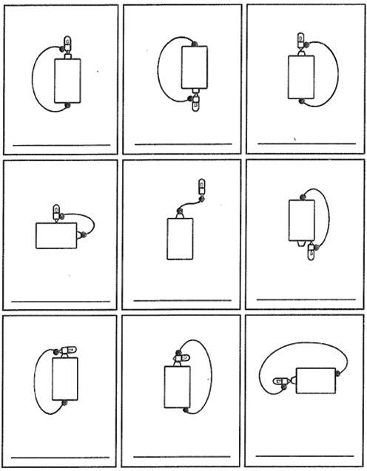Each picture shows a battery, light bulb, and wire. Decide whether each bulb will light up and write either YES or NO under each picture.
2. What is a closed circuit?
3. What is an open circuit?

**Circuit Symbols**

4. Draw the symbol for each of the circuit parts.

|  |  |  |  |  |  |
| --- | --- | --- | --- | --- | --- |
| Wire |  | Resistor |  | Bulb |  |
| Battery |  | Switch |  | Connected Wires |  |

**Series and Parallel Circuits**

5. Under each circuit diagram, circle whether the circuit is SERIES or PARALLEL.

|  |  |  |  |  |  |
| --- | --- | --- | --- | --- | --- |
|  | |  | |  | |
| Circle one:  **SERIES** or **PARALLEL** | |  | | Circle one:  **SERIES** or **PARALLEL** | | Circle one:  **SERIES** or **PARALLEL** | |

6. Explain how you can tell the difference between a series circuit and a parallel circuit.

______________________________________________________________________________________________________________________________________________________________________________

_______________________________________________________________________________________

**Circuit Diagrams**

7. **Draw** and **label** the circuit diagram for this circuit in the box to the right.

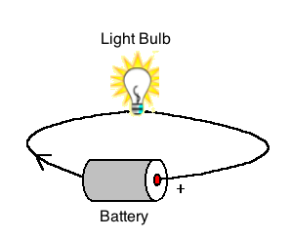

8. **Draw** and **label** the circuit diagram for this circuit.

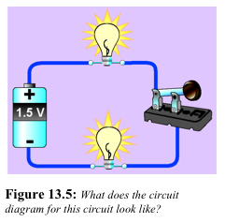

**Fill in the Blanks:**

9. The part of an atom that moves to create electricity is the ________________________.

10. The flow of electrons is called electric ___________________. This only happens if there is a complete path with no holes or gaps.

11. The loop of wire that the electrons flow through is called a _____________________.

12. A circuit in which all electrons follow a single pathway is a ____________________ circuit.

13. A circuit in which electrons follow multiple pathways is a ___________________ circuit.

14. If one light bulb goes out in a series circuit, the other light bulbs will __________ ___________.

15. What are the two things electrical current needs?

a. __________________________________________________________________________________________

b.___________________________________________________________________________________________

**Long Answer:**

16. Are household circuits connected in parallel or series? Explain your answer.

_______________________________________________________________________________________

______________________________________________________________________________________________________________________________________________________________________________

______________________________________________________________________________________________________________________________________________________________________________