**# _____**

Name _____________________

Date_________________________

**Disney - The Science of Imagineering - Energy**

1. Energy is the ability to do ______________________, which is the transfer __________________.
2. What is mechanical energy? ________________________________________________________
3. The center steering wheel of the cups in the mad tea party ride are used to:  
   a. spin the cup  b. move the cup up and down  c. drive the cup over the track
4. The Law of Conservation of Energy states the energy cannot be _________________________ or _________________________.
5. The final result of the work energy process is _____________ energy.
6. In the water slide, how do the riders put their own energy into the system?  
   a. by crossing their arms and legs  b.by walking up the stairs  c. by turning on the water
7. As you slide down the waterslide, the potential energy is converted to _______________________ energy.
8. What type of energy powers the cars on the Test Track?  
   a. hydraulics  b. gravity  c. electricity
9. What renewable energy is used at Disney?   
   a. wind  b. hydroelectric  c. solar panels
10. On Expedition Everest, what happens to the train when it reaches the broken tracks?  
    a. it reverses direction  b. it jumps over the tracks  c.it goes into a corkscrew turn

**Potential and Kinetic Energy Introduction**

**Use the yellow textbook to complete this section of notes, pages 121-127 D.**

1. How are work and energy related?

Define Potential Energy:

List three examples of potential energy.

Define Kinetic Energy:

List three examples of kinetic energy.

What is gravitational potential energy?

What is the equation for calculating KE?

What is the equation for calculating GPE?

1. If you lift a 2kg box of toys to the top shelf of a closet, which is 3 meters high, how much gravitational potential energy will the box of toys have?
2. A grasshopper with a mass of 0.002kg jumps up at a speed of 15 m/s. What is the kinetic energy of the grasshopper?
3. Explain how mechanical energy is related to kinetic and potential energy.
4. At each letter on the diagram below, indicate how the skater’s potential and kinetic energy changes as she skates up and down the ramp. Draw a circle graph for each letter like the example provide in the textbook.

A. B.

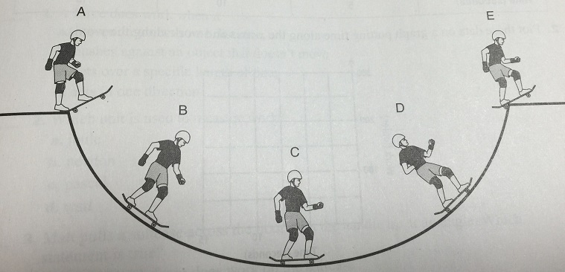

C. D.

E.

6. For each of the following, indicate if it is showing potential energy (PE) or kinetic energy (KE).

[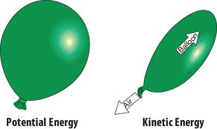](http://www.google.com/imgres?q=potential+energy+pictures&sa=X&hl=en&biw=1440&bih=719&tbm=isch&tbnid=rDwrD6ZELbINxM:&imgrefurl=http://www.glogster.com/tbaby20/kinetic-and-potential-energy/g-6lu7a66ccekgp2p0so73mia&docid=M7eAoN5zZ_oLnM&imgurl=http://b1969d.medialib.glogster.com/media/170098b1245cb1dbd5ef1c98ec6a66cbd78d867532d4ad0b28d8c42413112e7e/kinetic-and-potential-energy-l.jpg&w=800&h=476&ei=pppuUYX3LoHG9gT_jYBY&zoom=1&iact=hc&vpx=156&vpy=333&dur=3235&hovh=173&hovw=291&tx=60&ty=94&page=2&tbnh=146&tbnw=246&start=28&ndsp=36&ved=1t:429,r:36,s:0,i:260)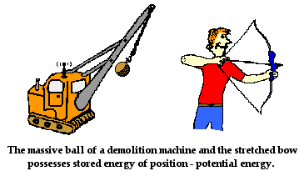

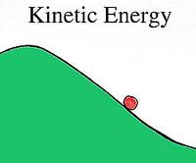[](http://www.google.com/imgres?q=potential+energy+pictures&sa=X&hl=en&biw=1440&bih=719&tbm=isch&tbnid=rDwrD6ZELbINxM:&imgrefurl=http://www.glogster.com/tbaby20/kinetic-and-potential-energy/g-6lu7a66ccekgp2p0so73mia&docid=M7eAoN5zZ_oLnM&imgurl=http://b1969d.medialib.glogster.com/media/170098b1245cb1dbd5ef1c98ec6a66cbd78d867532d4ad0b28d8c42413112e7e/kinetic-and-potential-energy-l.jpg&w=800&h=476&ei=pppuUYX3LoHG9gT_jYBY&zoom=1&iact=hc&vpx=156&vpy=333&dur=3235&hovh=173&hovw=291&tx=60&ty=94&page=2&tbnh=146&tbnw=246&start=28&ndsp=36&ved=1t:429,r:36,s:0,i:260)

(wrecking ball) (ball)

a. __________ b. __________ c. ____________ d. _____________

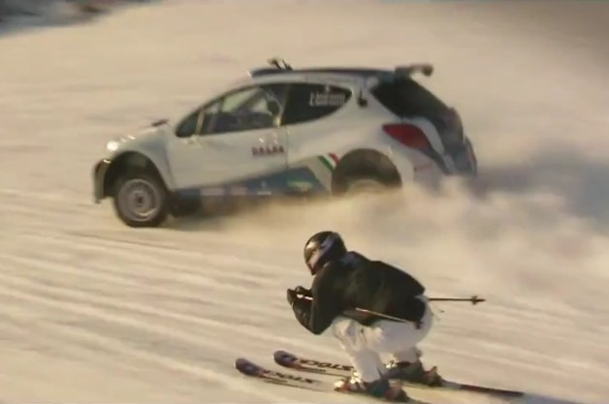[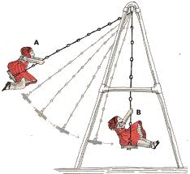](http://www.google.com/imgres?q=swinging+potential+energy&hl=en&biw=1440&bih=719&tbm=isch&tbnid=cvnfOo3yXhJ_IM:&imgrefurl=http://www.ltisdschools.org/site/default.aspx?PageType=3&ModuleInstanceID=11298&ViewID=7b97f7ed-8e5e-4120-848f-a8b4987d588f&RenderLoc=0&FlexDataID=12412&PageID=9920&docid=Gc7AJwjHCLjYlM&imgurl=http://www.ltisdschools.org/cms/lib/TX21000349/Centricity/Domain/522/swinging.gif&w=500&h=459&ei=rJtuUabOEY6K9QSbrYDwAQ&zoom=1&iact=hc&vpx=562&vpy=67&dur=1109&hovh=215&hovw=234&tx=121&ty=140&page=1&tbnh=135&tbnw=147&start=0&ndsp=27&ved=1t:429,r:2,s:0,i:87)[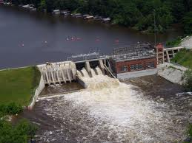](http://www.google.com/imgres?q=water+in+dam&hl=en&biw=1440&bih=719&tbm=isch&tbnid=z-CG0oiCtHl0yM:&imgrefurl=http://www.sflecc.com/&docid=gzfVlT3nFdd_kM&imgurl=http://www.sflecc.com/Oakdale%2008%20High%20-%20Oakdale%20Dam%20(2).JPG&w=1600&h=1200&ei=cJ1uUaCcG5D89gSXiYCwBA&zoom=1&iact=hc&vpx=711&vpy=407&dur=3203&hovh=194&hovw=259&tx=130&ty=157&page=1&tbnh=148&tbnw=200&start=0&ndsp=26&ved=1t:429,r:23,s:0,i:155)

A

A

B

**B**

e. water at point A. ________ g. girl at point A. _______ i. both the skier and the rally car

f**.** water at point B. ________ h. girl at point B. _______ as they go downhill ________

[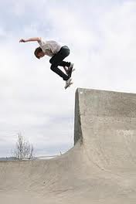](http://www.google.com/imgres?q=skateboarding&hl=en&biw=1440&bih=719&tbm=isch&tbnid=TsmSQBO0x80J8M:&imgrefurl=http://en.wikipedia.org/wiki/Skateboarding&docid=Jp_eU6vVQ2gRcM&imgurl=http://upload.wikimedia.org/wikipedia/commons/thumb/c/c0/BackSmithGrind.jpg/220px-BackSmithGrind.jpg&w=220&h=330&ei=EJ1uUe_HCYnu8QTrooG4Ag&zoom=1&iact=hc&vpx=2&vpy=336&dur=2781&hovh=264&hovw=176&tx=59&ty=159&page=1&tbnh=148&tbnw=95&start=0&ndsp=35&ved=1t:429,r:18,s:0,i:201)

[](http://www.google.com/imgres?q=baseball+clipart+images&hl=en&biw=1440&bih=719&noj=1&tbm=isch&tbnid=nrcVTzAJw_d5BM:&imgrefurl=http://www.illustrationsof.com/1061747-royalty-free-baseball-clipart-illustration&docid=komMKL95arLKaM&imgurl=http://www.illustrationsof.com/royalty-free-baseball-clipart-illustration-1061747.jpg&w=400&h=420&ei=pp9uUbOrN4a-9gS8u4DYBw&zoom=1&iact=hc&vpx=984&vpy=177&dur=3093&hovh=230&hovw=219&tx=117&ty=119&page=3&tbnh=140&tbnw=133&start=82&ndsp=46&ved=1t:429,r:89,s:0,i:371)

skateboarder

(the arrow)

j. __________ k. _________ l. __________

1. Look at the pendulum below.
   1. At what point in its motion is the kinetic energy of the pendulum the greatest (label with 🡹 **KE**)?
   2. At what point is its potential energy greatest (label with 🡹 **PE**)?
   3. When its kinetic energy is half its greatest value, how much potential energy did it gain?

