Name______________________________

Date __________________ Period ______

**# ______**

**Dew You Get the Point?**

**Part 1: Relative Humidity**

1. Record the temperatures provided in class for the wet and dry bulbs. Find the difference in the wet and dry bulb temperatures for both inside and outside and record those numbers in the data table. Use the **Relative Humidity Chart** on **page R53** in the yellow textbook to find the relative humidity inside and outside and record it in the data table.

|  |  |  |  |  |
| --- | --- | --- | --- | --- |
| **Location** | **Wet Bulb** | **Dry Bulb** | **Difference** | **Relative**  **Humidity** |
| Inside |  |  |  |  |
| Outside |  |  |  |  |

Use the **Relative Humidity Chart** to complete the following questions:

1. In a kitchen, the dry bulb reading is 28°C and the wet bulb reading is 22°C, determine the relative humidity of that room. __________________
2. The smaller the difference in the dry and wet bulb temperatures on a sling psychrometer, the (higher or lower) _________________ the relative humidity.
3. A humid bathroom has a dry bulb reading of 30°C and a wet bulb reading of 28°C. Determine the relative humidity. ________________
4. If a room has a relative humidity of 76% and the difference in the temperatures of the wet and dry bulbs is 3 degrees, find the temperature of the room. ___________________
5. Determine the wet bulb temperature of an area with a temperature of 14°C and a relative humidity of 25%.

_________________

1. By studying the chart, you can determine that… **WARM AIR CAN HOLD MORE WATER THAN ____________ AIR.**

**Part 2: Dew Point**

**Procedure:**

1. Record the temperature of the air in the classroom (in °C) in the data table on your lab results sheet.
2. Make sure the metal cup is clean and dry. Fill the metal cup half way with room temperature water.
3. Place the thermometer in the water.
4. Add ice to the water and gently stir.
5. Carefully observe the sides of the cup. Once you begin to see condensation form consistently on the exterior of the cup, record the temperature of the thermometer (°C). Repeat steps 2-5, then average your data.

**Average Dew Point Temperature**

|  |  |  |
| --- | --- | --- |
| **Air Temperature (°C)** | **Trial** | **Dew Point (°C)** |
|  | **1** |  |
|  | **2** |  |
|  | **3** |  |

The average dew point temperature in the classroom is _____________ (°C).

If you were to complete this activity again tomorrow and found that the dew point had increased, would this indicate that there was more moisture (water vapor) in the air or less? Why? (Assume the air temperature is the same.)

**Part 3: Water in the Atmosphere Analysis**

*Use the graph below to answer the following questions.*

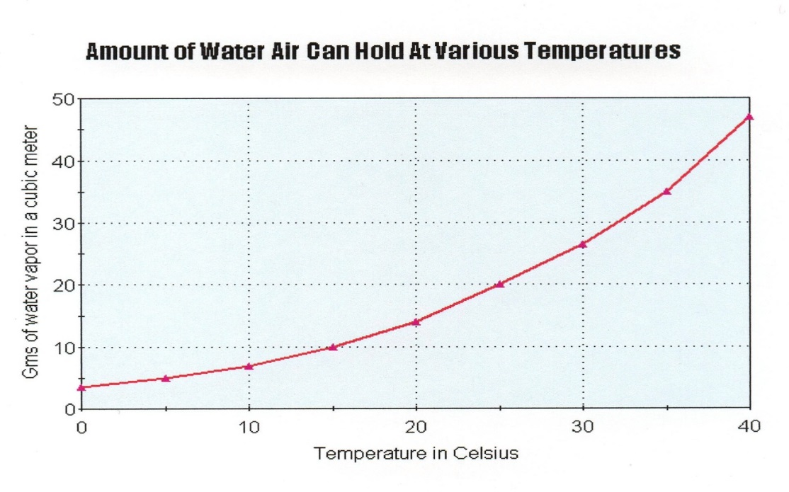

1. According to the graph, what is the relationship between temperature and the amount of water vapor a certain volume of air can hold?

2. According to the graph, which can hold more water vapor? Polar air or Tropical air? Explain why.

3. According to the graph, what amount of water vapor can the air hold at 25° C? ___________________

4. According to the graph, what amount of water vapor does the air actually hold if the dew point is 15 °C?

*Use the Relative Humidity and Dew Point Tables to fill in the following charts and answer the questions.*

|  |  |  |  |  |  |
| --- | --- | --- | --- | --- | --- |
| Trial | Dry Bulb  (°C) | Wet Bulb  (°C) | Difference Between  Wet & Dry Bulbs | Dew Point  (°C) | Relative Humidity  (%) |
| 1 | 10 | 1 |  |  |  |
| 2 | 10 | 2 |  |  |  |
| 3 | 10 | 3 |  |  |  |
| 4 | 10 | 4 |  |  |  |
| 5 | 10 | 5 |  |  |  |
| 6 | 10 | 6 |  |  |  |
| 7 | 10 | 7 |  |  |  |
| 8 | 10 | 8 |  |  |  |
| 9 | 10 | 9 |  |  |  |
| 10 | 10 | 10 |  |  |  |

5. According to the chart, as the wet bulb temperature increases (dry bulb temperature stays the same) what happens to the dew point?

a) increases b) decreases c) remains the same

6. According to the chart, as the wet bulb temperature increases (dry bulb temperature stays the same) what happens to the relative humidity?

a) increases b) decreases c) remains the same

*Fill in the following chart below using the Relative Humidity and Dew Point Tables then answer the questions.*

|  |  |  |  |  |
| --- | --- | --- | --- | --- |
| Dry Bulb  (°C) | Wet Bulb  (°C) | Difference Between  Wet and Dry | Dew Point  (°C) | Relative Humidity  (%) |
| 12 | 12 |  |  |  |
| 14 | 12 |  |  |  |
| 16 | 12 |  |  |  |
| 18 | 12 |  |  |  |
| 20 | 12 |  |  |  |

7. As the dry bulb temperature increases (wet bulb stays the same) what happens to the dew point temperature?

a) increases b) decreases c) remains the same

8. As the dry bulb temperature increases (wet bulb stays the same) what happens to the relative humidity?

a) increases b) decreases c) remains the same

9. *Below are two diagrams of air.*

Represents an air molecule other than water vapor.

Represents a water vapor molecule.

**Diagram A Diagram B**



a. Which is a diagram of warm air? Explain.

b. Which is a diagram of cold air? Explain.

10. Explain why does a soda can “sweat” on a hot humid summer day?

11. When it is very hot and very humid, the news people tell us to take precautions because these are dangerous conditions. Think about what you know about how humans and other animals cool off. Explain why high heat with high humidity is especially dangerous.

12. Typically, it is much less humid during the winter than during the summer. Explain why.

13. Fill in the blanks in the sentences below using the word bank.

*evaporates water vapor dew condenses temperature condenses*

The dew point is the _______________ where moisture in the air _____________. As the sun’s heat

______________ water, the water changes to an invisible gas called ___________ __________. When the temperature cools down, the water vapor ______________, or turns the gas back to a liquid. These drops of water are called ___________ and form on plants, windows, and cars.