**1600**

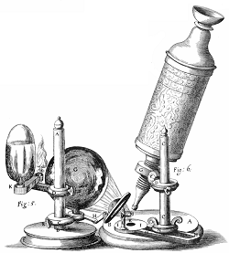

**1838**

**1665**

**Matthias Schleiden**

Born:

Died:

From:

Education:

Profession:

Important Discovery Related to Cells:

Other Contributions:

Known as:

**Robert Hooke**

Born:

Died:

From:

Education:

Profession:

Important Discovery Related to Cells:

Other Contributions:

Known as:

**Anton van Leeuwenhoek**

Born:

Died:

From:

Education:

Profession:

Important Discovery Related to Cells:

Other Contributions:

Known as:

**1800**

**1700**

**1673**