**1839**

**Theodore Schwann**

Born:

Died:

From:

Education:

Profession:

Important Discovery Related to Cells:

Other Contributions:

Known as:

**Rudolf Virchow**

Born:

Died:

From:

Education:

Profession:

Important Discovery Related to Cells:

Other Contributions:

Known as:

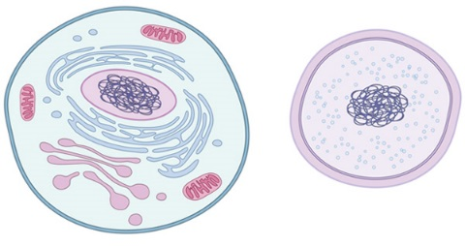

What are the components of the Cell Theory?

1.

2.

3.

**1900**

**1858**