Review Stations – Cells
Name ______________________

Station 1 - Plant Cell
Only in Plant Cells
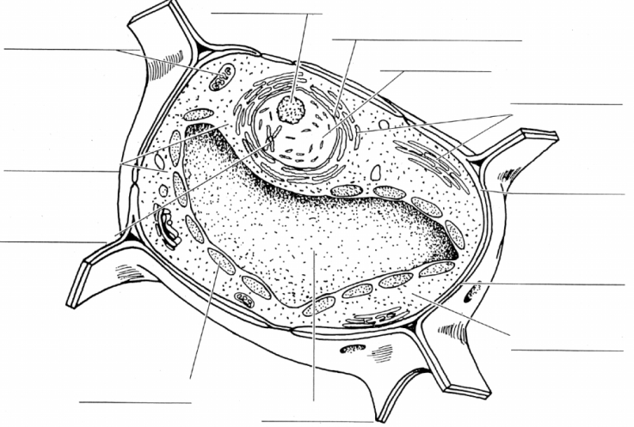

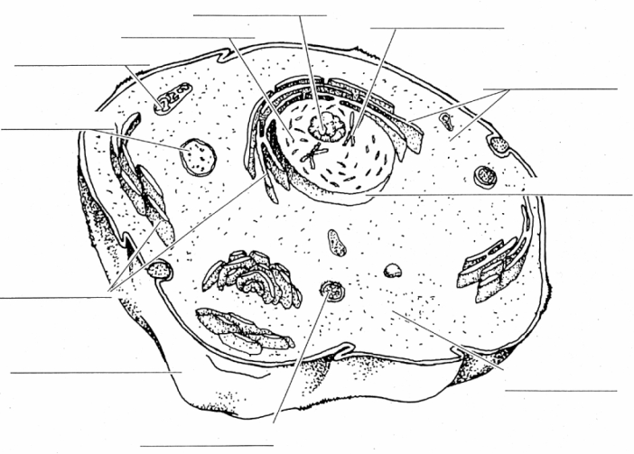
Station 2 – Animal Cells
Only in Animal Cells

Station 3 – Protists

Station 3 – Protists
Name
Structure for movement
How it obtains food
How it reproduces
Plant-like, animal-like or both?

Station 4 – Cells

Eukaryotic Cells | Prokaryotic Cells |  | Unicellular Organisms | Multicellular Organisms

Station 5 – Cell Theory

Scientists | Contributions

Cell Theory:
1.

2.

3.

Station 6 – Characteristics of Living Things
1.
a.

b.

c.

d.

e.

f.

2.

Station 7 – Compare and Contrast

Station 8 – Quizizz
Record your score: ___________________

