Anton van Leeuwenhoek
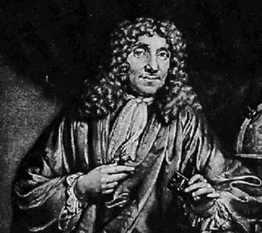
Anton van Leeuwenhoek was not a scientist, but just very curious about the world around him. That curiosity led him to the discoveries that earned him the title of the “Father of Microscopy”. He was born in Delft, Holland on October 24, 1632 to a family of tradesmen. He went to primary school in his hometown, but never received any higher education or university degrees. He left home at the age of fourteen to apprentice in a draper’s shop. A draper was a fabric merchant. In 1654, he returned home to Delft where he opened his own draper’s shop and remained until his death on August 30, 1723.
Anton van Leeuwenhoek became interested in microscopy after having seen Robert Hooke’s Micrographia. In his business, magnifying glasses were used to count the number of threads in cloth. The higher the thread count, the finer the cloth. He combined his passion of striving to make better magnifying devices with his curiosity and made over 500 microscopes in his lifetime. His microscopes were not compound, or made with more than one lens, like the one made by Robert Hooke, but his strongest ones were able to magnify over 250 times.
His skill at grinding his own lenses and adjusting the lighting perfectly allowed him to get clearer and better images than any other scientists at the time. He would observe anything that he was able to get under his lens and was skilled at giving very detailed and technical descriptions of what he saw. In 1673, he was the first person to observe single-celled animals or protists. He described these single cell organisms that he saw in a drop of pond water as animalcules or little animals. He sent letters about his discoveries to the Royal Society, a group of distinguished scientists formed in 1660 that is still in existence today.
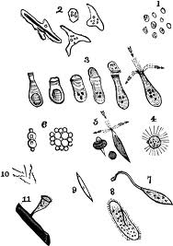
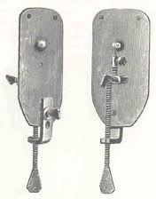
Leeuwenhoek became famous as he continued to make new discoveries that the Royal Society translated and published. In 1683, he was the first to observe living bacteria while studying plaque from his own and other people’s teeth. He was the first person to observe and describe blood cells, microscopic nematodes and rotifers and much more. He also studied the structure of plants, the compound eyes of insects and the life cycles of fleas, aphids and ants. Joining other highly regarded scientists of the day, he was honored by being elected a full member of the Royal Society in 1680.

Leeuwenhoek’s
“animalcules”
Leeuwenhoek’s
hand-held microscope

